Spring Data JPA - Quick Example
Software Pre-requisites
- MySQL Server 8.0
- MySQL Workbench 8
- Eclipse IDE for Enterprise Java Developers 2019-03 R
- Maven 3.6.2
Create a Eclipse Project using Spring Initializr
- Go to https://start.spring.io/
- Change Group as “com.cognizant”
- Change Artifact Id as “orm-learn”
- In Options > Description enter "Demo project for Spring Data JPA and Hibernate"
- Click on menu and select "Spring Boot DevTools", "Spring Data JPA" and "MySQL Driver"
- Click Generate and download the project as zip
- Extract the zip in root folder to Eclipse Workspace
- Import the project in Eclipse "File > Import > Maven > Existing Maven Projects > Click Browse and select extracted folder > Finish"
- Create a new schema "ormlearn" in MySQL database. Execute the following commands to open MySQL client and create schema.

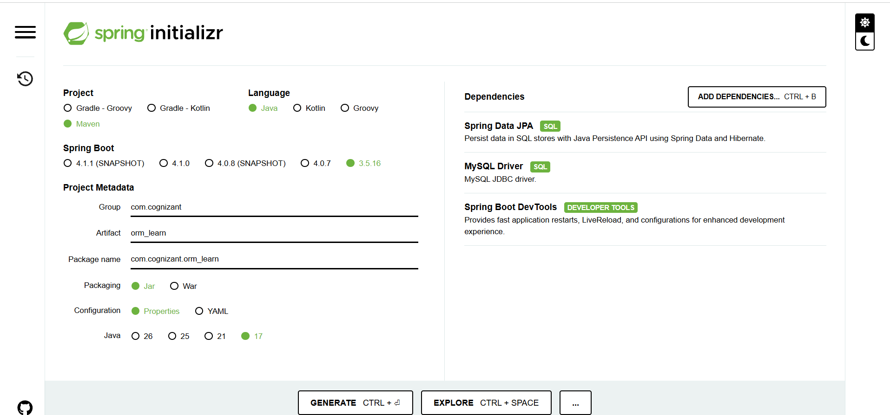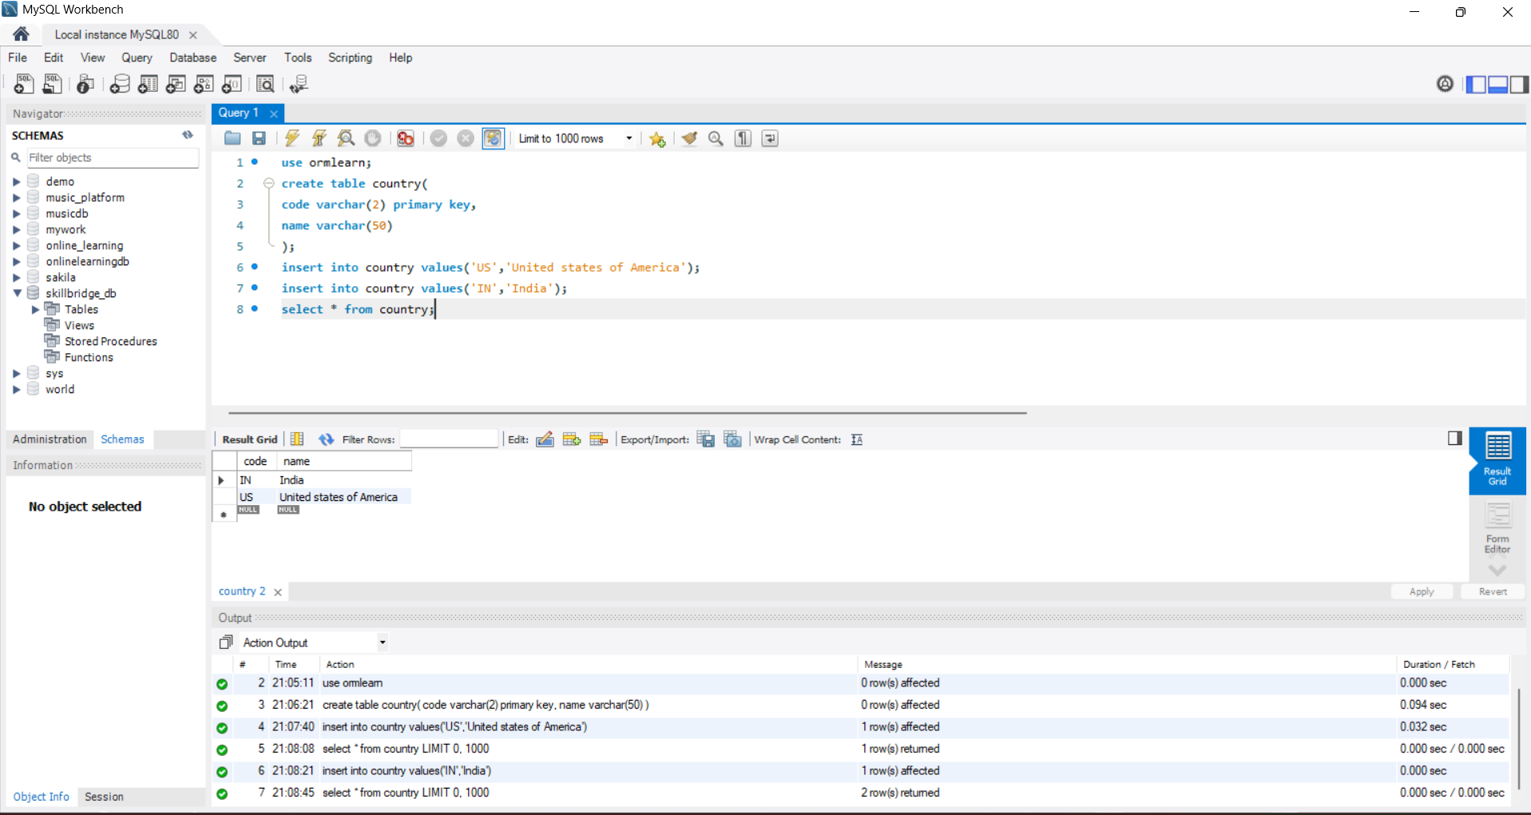

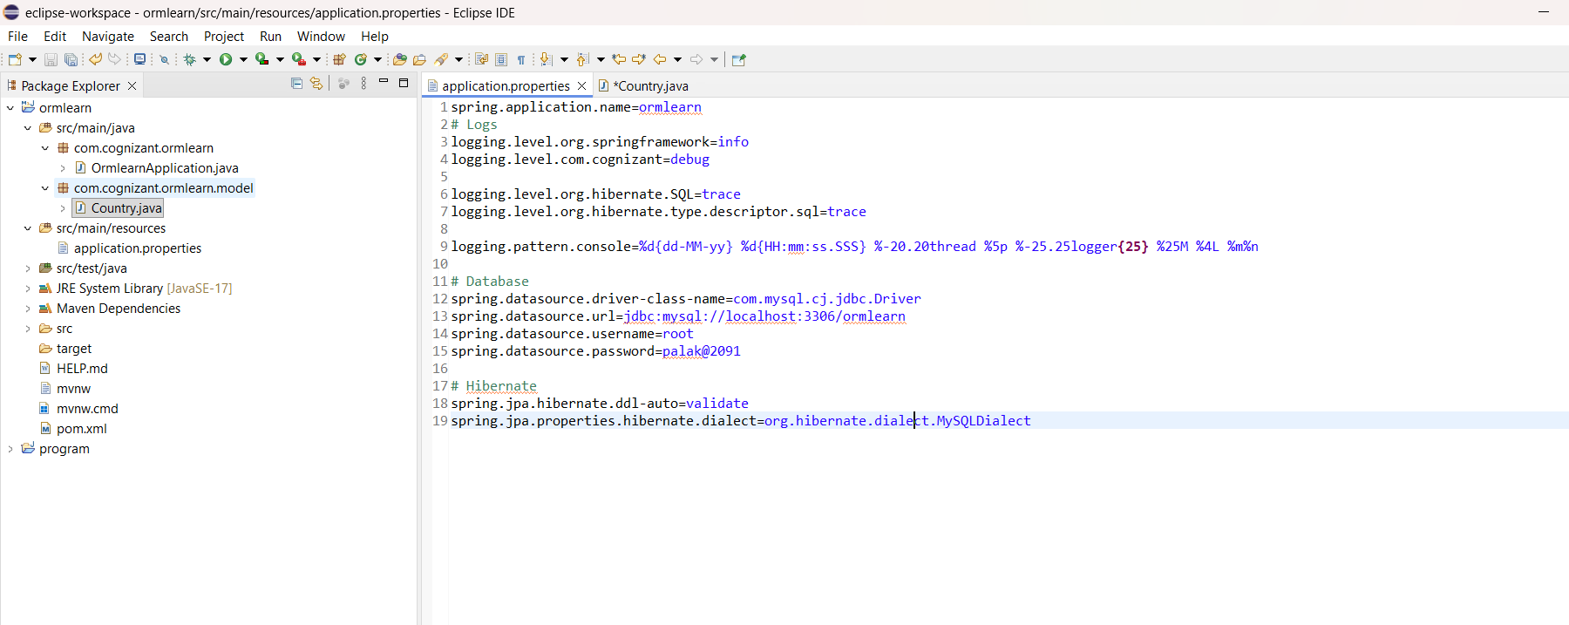
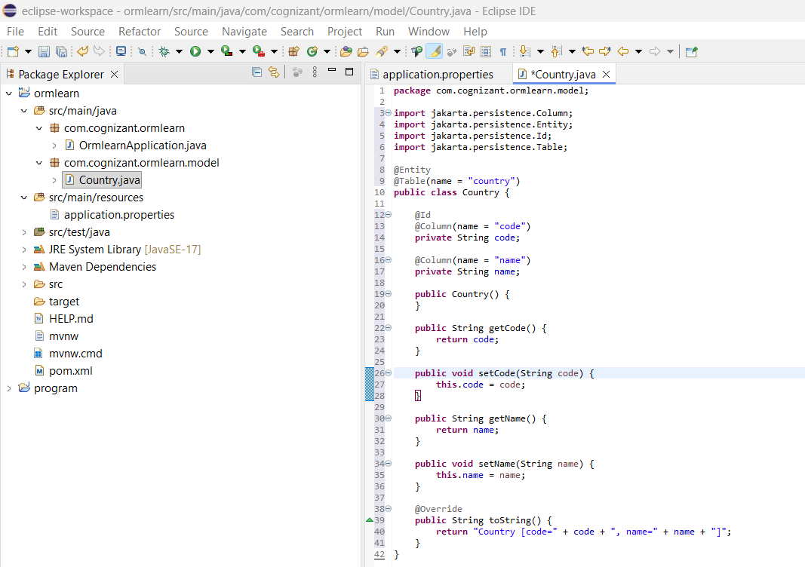
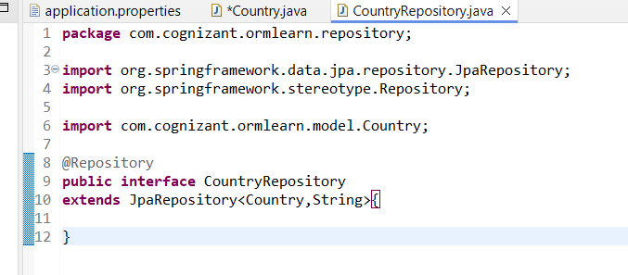
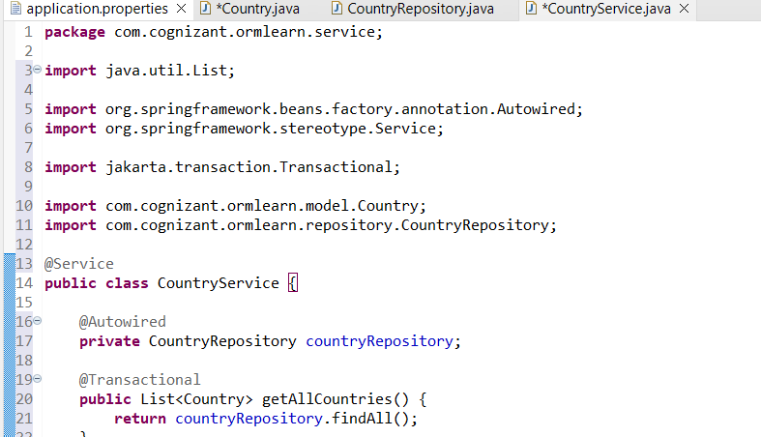

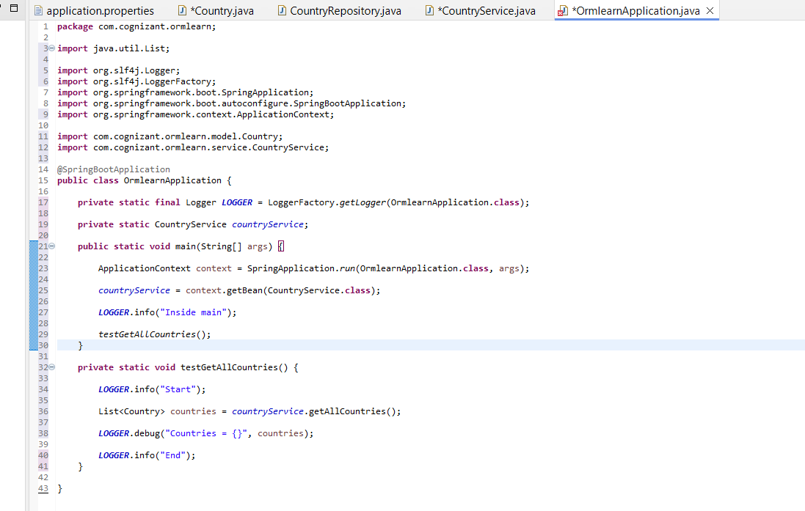
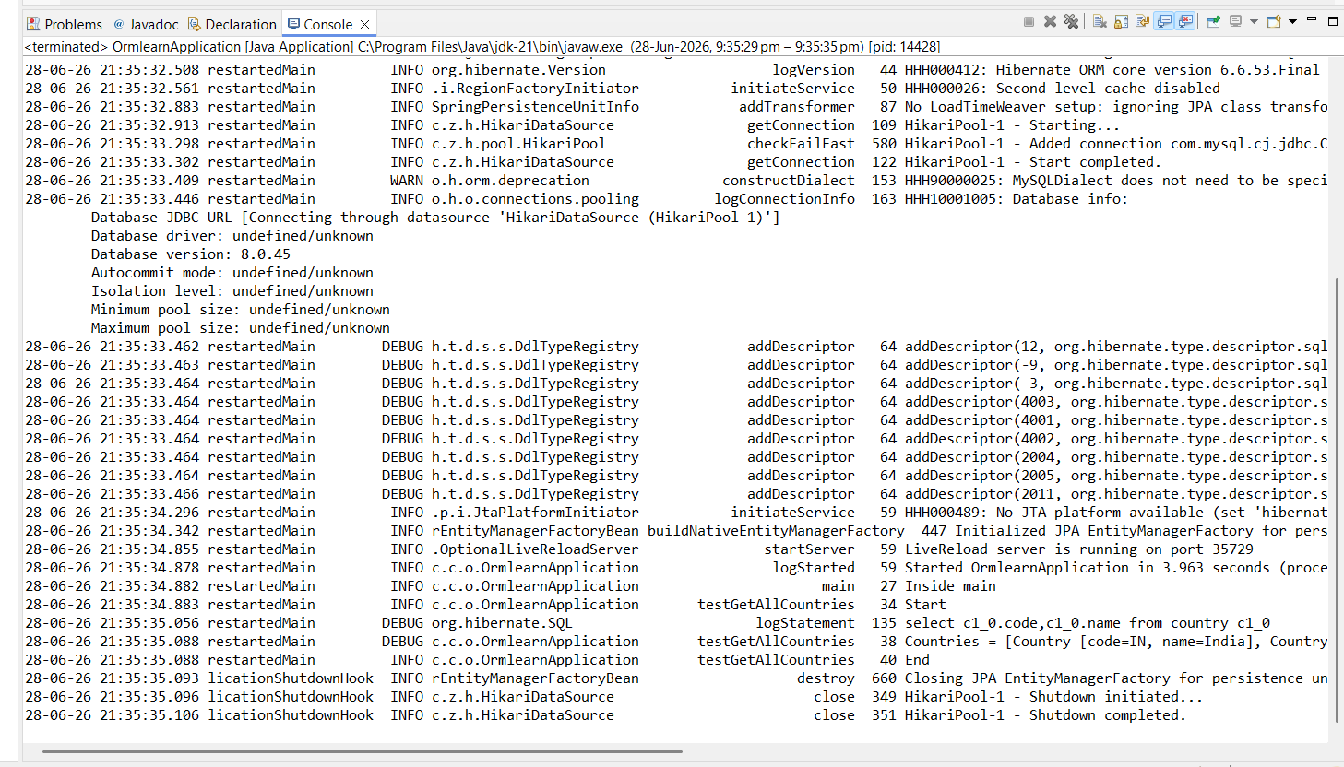

Difference between JPA, Hibernate and Spring Data JPA
Difference between JPA, Hibernate and Spring Data JPA
1. JPA (Java Persistence API)
Definition:
JPA is a specification (set of rules/interfaces) that defines how Java objects should be mapped to database tables. It is not an implementation, so it cannot perform database operations by itself.
Example:
Suppose we have a Country class. JPA provides annotations such as @Entity, @Table, and @Id to map this class to the country table.
@Entity
@Table(name = "country")
public class Country {
@Id
private String code;
private String name;
}
Key Point:
JPA only defines what should be done, not how it is done. It requires an implementation like Hibernate.

2. Hibernate
Definition:
Hibernate is an ORM (Object Relational Mapping) framework and one of the most popular implementations of JPA. It converts Java objects into database records and generates SQL queries automatically.
Example:
Country country = entityManager.find(Country.class, "IN");
Hibernate internally generates SQL similar to:
SELECT * FROM country WHERE code = 'IN';
Key Point:
Hibernate implements JPA and performs all the actual database operations such as saving, updating, deleting, and retrieving data.

3. Spring Data JPA
Definition:
Spring Data JPA is a Spring module built on top of JPA. It further simplifies database programming by automatically implementing repository methods, reducing boilerplate code.
Example:
@Repository
public interface CountryRepository extends JpaRepository<Country, String> {

}
Now we can directly use:
countryRepository.findAll();
countryRepository.findById("IN");
countryRepository.save(country);
countryRepository.deleteById("IN");
without writing any SQL or implementation.
Key Point:
Spring Data JPA reduces coding effort by providing ready-made CRUD operations and query methods.

Comparison Table
Feature | JPA | Hibernate | Spring Data JPA
Type | Specification | ORM Framework (Implementation of JPA) | Spring Module
Can work independently? | No | Yes | No (requires JPA implementation like Hibernate)
Main Purpose | Defines persistence rules | Implements JPA and performs ORM | Simplifies database access using repositories
SQL Writing | Not applicable | Generates SQL automatically | Uses Hibernate to generate SQL automatically
Boilerplate Code | More | Moderate | Very Less
CRUD Operations | Using EntityManager | Using Session/EntityManager | Using JpaRepository
Real-Time Example
Suppose we want to fetch all countries from the database.
Using JPA
List<Country> countries =
entityManager.createQuery("from Country", Country.class)
.getResultList();
Using Hibernate
Session session = sessionFactory.openSession();
List<Country> countries =
session.createQuery("from Country", Country.class).list();
Using Spring Data JPA
List<Country> countries = countryRepository.findAll();
Spring Data JPA internally calls Hibernate, and Hibernate generates the SQL query automatically.
Conclusion:
JPA defines the standard rules for persistence, Hibernate implements those rules and performs the ORM operations, while Spring Data JPA sits on top of JPA to simplify development by providing ready-made repository methods such as findAll(), save(), findById(), and deleteById().

